### Paris Literary and Intellectual Network: Complete Storylines with Coordinates

#### 1. Victor Hugo

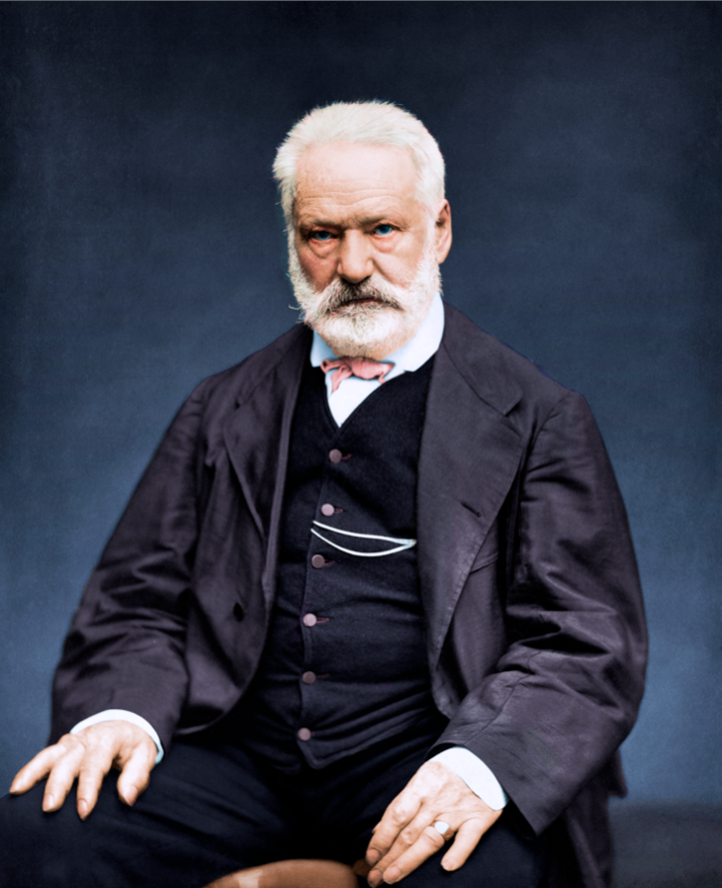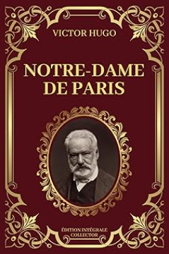

**Background:** Victor Hugo (1802–1885) was one of France’s greatest Romantic writers, known for his novels "Les Misérables" and "Notre-Dame de Paris" (The Hunchback of Notre-Dame). He was a leading figure in French literature and politics, advocating for freedom and social justice. Hugo spent much of his life in Paris, where he was an active figure in literary circles and a defender of the oppressed.

#### 2. Marcel Proust

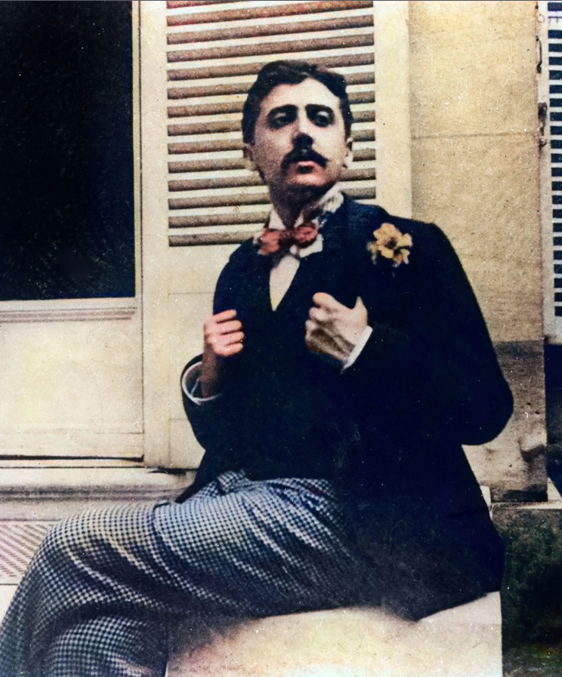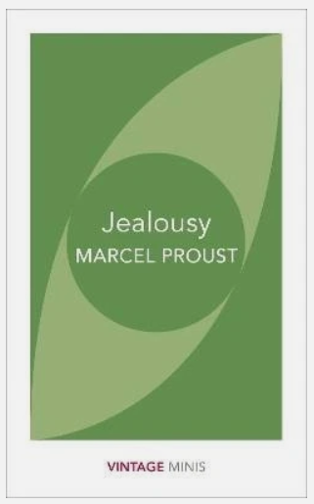

**Background:** Marcel Proust (1871–1922) was a French novelist best known for his work "In Search of Lost Time" (À la recherche du temps perdu), a monumental exploration of memory and society. He was a key figure in French modernist literature and was known for his reclusive lifestyle but remained connected to the Parisian literary elite.

#### 3. Jean-Paul Sartre and Simone de Beauvoir

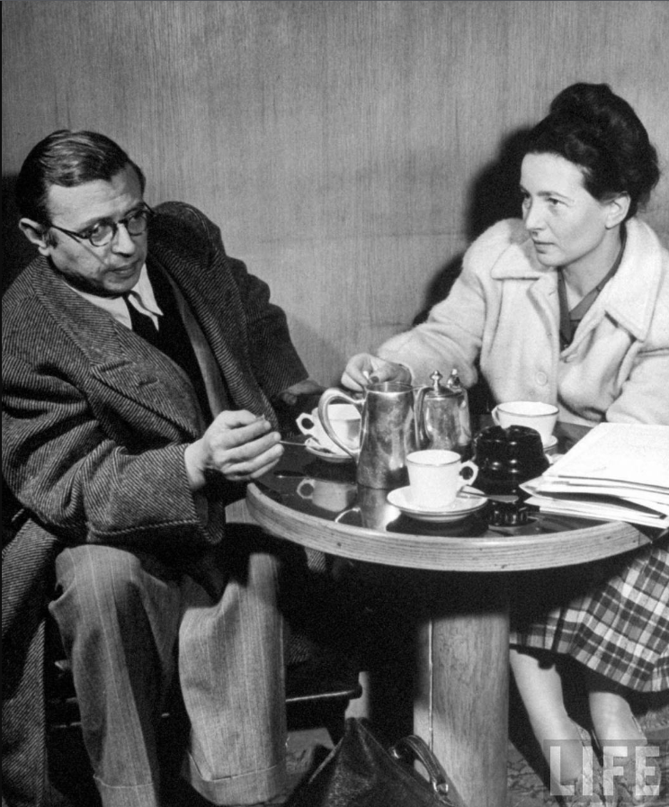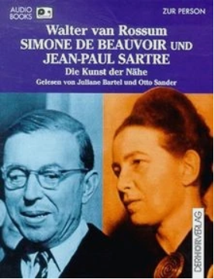

**Background:** Jean-Paul Sartre (1905–1980) and Simone de Beauvoir (1908–1986) were French existentialist philosophers and writers who shaped 20th-century intellectual thought. They were iconic figures of the Left Bank, frequenting cafés and engaging in passionate debates on philosophy, literature, and politics.

#### 4. Émile Zola

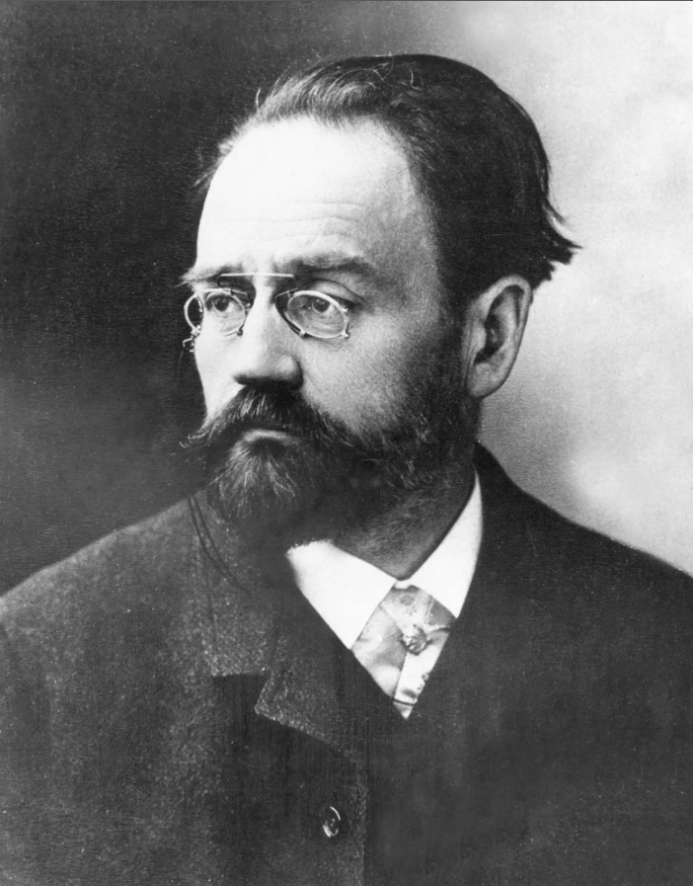

**Background:** Émile Zola (1840–1902) was a major figure in French naturalism and an outspoken advocate for social justice. His famous open letter "J'accuse" defended Alfred Dreyfus, making him a national symbol of free speech.

#### 5. George Sand

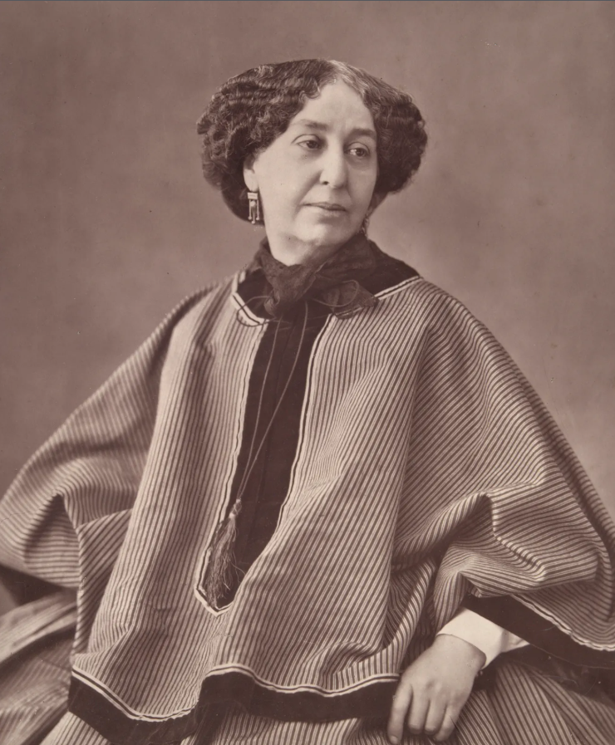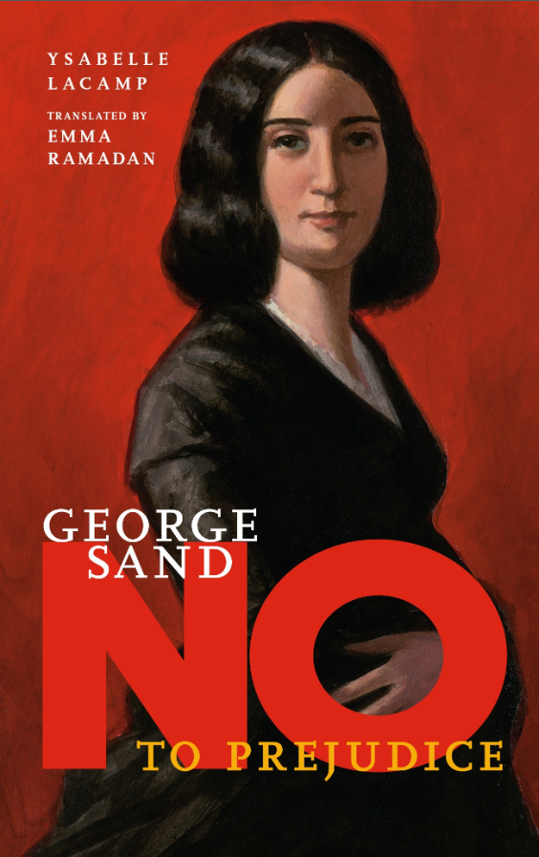

**Background:** George Sand (1804–1876), pseudonym of Amantine Lucile Aurore Dupin, was a French novelist known for her unconventional lifestyle and works promoting social equality and women’s rights.

#### 6. Honoré de Balzac

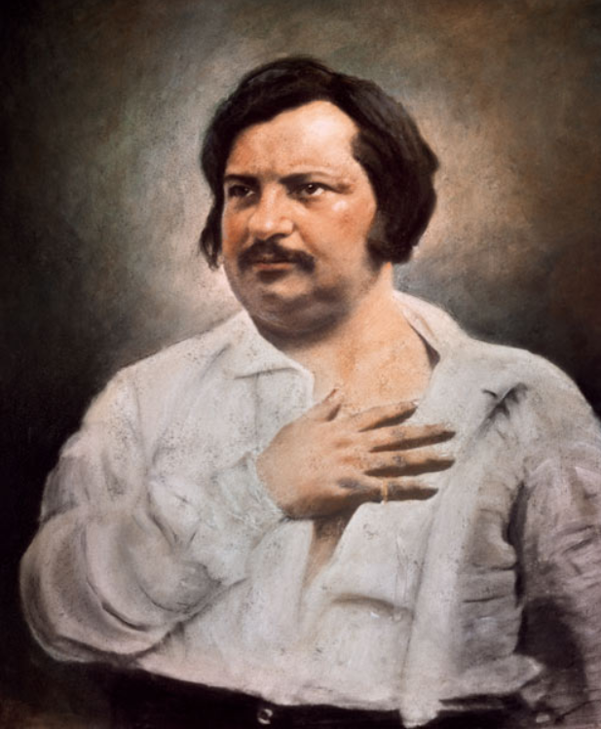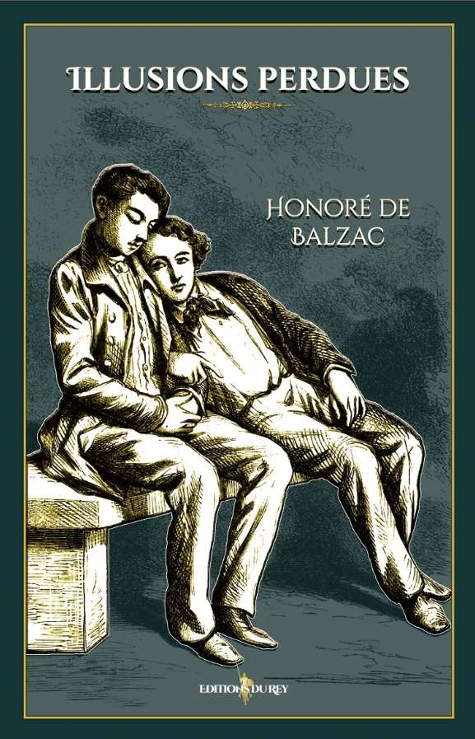

**Background:** Honoré de Balzac (1799–1850) was one of France’s greatest novelists, known for his massive series "La Comédie Humaine" which depicted French society in the 19th century.

#### 7. Charles Baudelaire

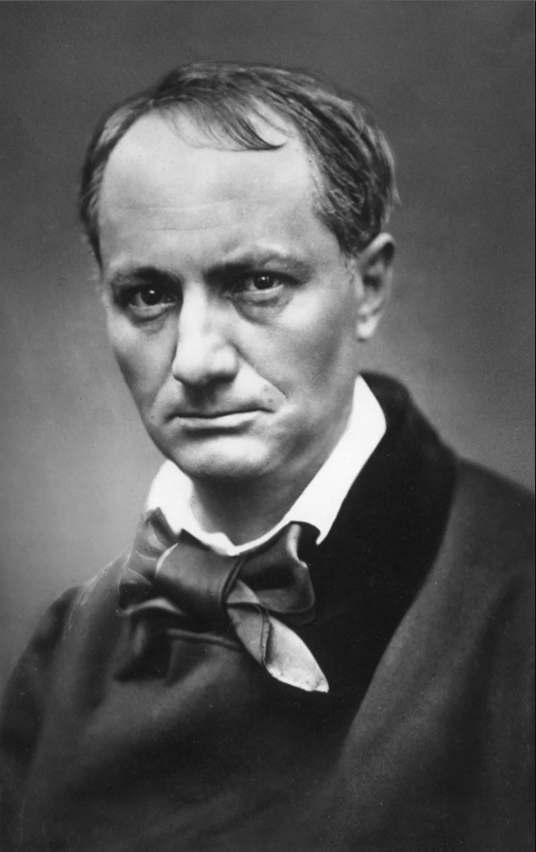

**Background:** Charles Baudelaire (1821–1867) was a pioneering French poet known for his work "Les Fleurs du mal" (The Flowers of Evil), which transformed French poetry with its themes of beauty, decadence, and the urban experience.

#### 8. Guillaume Apollinaire



**Background:** Guillaume Apollinaire (1880–1918) was a French poet and critic who was a central figure in the Parisian avant-garde, known for works like "Alcools" and "Calligrammes".

#### 9. Albert Camus

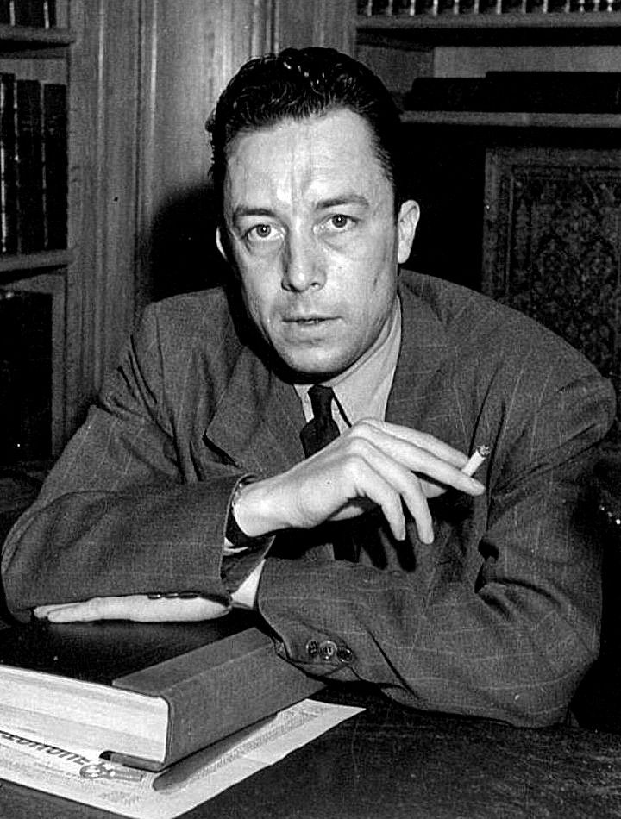

**Background:** Albert Camus (1913–1960) was a French philosopher, writer, and journalist known for his concept of the absurd and works like "The Stranger" and "The Myth of Sisyphus".

## ****10. Paul Verlaine and Arthur Rimbaud****

**Background:** Paul Verlaine (1844–1896) and Arthur Rimbaud (1854–1891) were two of France’s most famous Symbolist poets. Their turbulent relationship and poetic collaboration left a lasting mark on French literature.

